ISABE 2022 Workshop
Tutorial Worksheet
Design point performance – 1-spool turbojet engine (Classroom Example)

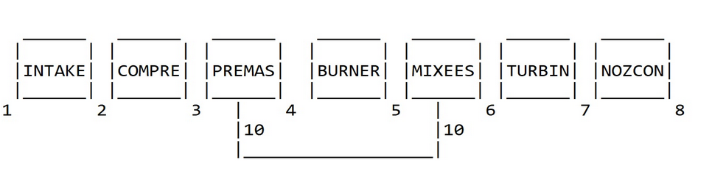
Compressor exit temperature, T₃ = _____________ K
Compressor work, CW = ___________ MW
Combustor heat input, Q_{in} = ________ MW
Fuel flow, W_{ff} = _________ kg/s
Turbine exit temperature, T₇ = ___________ K
Turbine exit pressure, P₇ = __________ bar
Nozzle exit pressure, P₈ = _________ bar
Nozzle exit temperature (static), t₈ = __________ K
Nozzle exit velocity, V₈ = _________ m/s
Nozzle exit area, A = _________ m²
Thrust, F_{N} = __________ N
Off-design performance – 1-spool turbojet (PCN =0.7)

Iteration 1
Guessed pressure ratio = ____________
From compressor map, corresponding NDMF = _____________
From compressor map, corresponding efficiency = ___________
Compressor exit temperature, T₃ = ________ K
Guessed ΔT₄₅ from combustor map = _________ K
Combustor exit temperature, T₅ = ___________ K
Combustor heat input, Q_{in} = ___________ MW
Combustor fuel flow, W_{ff} = ___________ kg/s
Guessed turbine ΔH/T = ___________
Corresponding turbine NDMF * CN = __________
Corresponding turbine efficiency = __________
Turbine exit temperature, T₇ = ___________ K
Turbine exit pressure, P₇ = ___________ bar
Rotational compatibility = Yes/No
Mass flow compatibility = Yes/No
Work compatibility = Yes/No
Iteration 1
Guessed pressure ratio = ____________
From compressor map, corresponding NDMF = _____________
From compressor map, corresponding efficiency = ___________
Compressor exit temperature, T₃ = ________ K
Guessed ΔT₄₅ from combustor map = _________ K
Combustor exit temperature, T₅ = ___________ K
Combustor heat input, Q_{in} = ___________ MW
Combustor fuel flow, W_{ff} = ___________ kg/s
Guessed turbine ΔH/T = ___________
Corresponding turbine NDMF * CN = __________
Corresponding turbine efficiency = __________
Rotational compatibility = Yes/No
Mass flow compatibility = Yes/No
Work compatibility = Yes/No
Performance calculation
Nozzle exit pressure, P₈ = _________ bar
Nozzle exit temperature (static), t₈ = __________ K
Nozzle exit velocity, V₈ = _________ m/s
Thrust, F_{N} = __________ N

Simulation Exercise 1

SL | Operating condition | Compressor
 |  | Pressure ratio | Exit temperature | Efficiency | Work
1 | Design point
 | TET = 1141K
2 | OP1
 | TET = 900K
3 | OP2
 | TET = 1000K
4 | OP3
 | TET = 1200K
5 | OP4
 | TET = 1300K

SL | Operating condition | Turbine
 |  | Pressure ratio | Exit temperature | Efficiency | Work
1 | Design point
 | TET = 1141K
2 | OP1
 | TET = 900K
3 | OP2
 | TET = 1000K
4 | OP3
 | TET = 1200K
5 | OP4
 | TET = 1300K

SL | Operating condition | Performance
 |  | Net thrust | SFC | Mass flow | Fuel flow
1 | Design point
 | TET = 1141K
2 | OP1
 | TET = 900K
3 | OP2
 | TET = 1000K
4 | OP3
 | TET = 1200K
5 | OP4
 | TET = 1300K

Simulation Exercise 2

SL | Operating condition | Compressor
 |  | Pressure ratio | Exit temperature | Efficiency | Work
1 | Design point
 | 0, 0, 0
2 | OP1
 | 0, -15, 0
3 | OP2
 | 2000, -10, 0.5
4 | OP3
 | 5000, 0, 0.6
5 | OP4
 | 8000, 10, 0.7
6 | OP5
 | 10000, 0, 0.8
7 | OP6
 | 6000, 20, 0.8
8 | OP7
 | 0, 0, 0.6

SL | Operating condition | Turbine
 |  | Pressure ratio | Exit temperature | Efficiency | Work
1 | Design point
 | 0, 0, 0
2 | OP1
 | 0, -15, 0
3 | OP2
 | 2000, -10, 0.5
4 | OP3
 | 5000, 0, 0.6
5 | OP4
 | 8000, 10, 0.7
6 | OP5
 | 10000, 0, 0.8
7 | OP6
 | 6000, 20, 0.8
8 | OP7
 | 0, 0, 0.6

SL | Operating condition | Performance
 |  | Net thrust | SFC | Mass flow | Fuel flow
1 | Design point
 | 0, 0, 0
2 | OP1
 | 0, -15, 0
3 | OP2
 | 2000, -10, 0.5
4 | OP3
 | 5000, 0, 0.6
5 | OP4
 | 8000, 10, 0.7
6 | OP5
 | 10000, 0, 0.8
7 | OP6
 | 6000, 20, 0.8
8 | OP7
 | 0, 0, 0.6

Simulation Exercise 3

Operating condition | Compressor faults |  |  | Turbine faults
 | PR Deg | FC Deg | ETA Deg | DH deg | TF deg | ETA deg
OP1 | 0% | -1% | -2% | 0% | 0% | 0%
OP2 | -2% | 0% | 0% | 0% | 0% | -2%
OP3 | 0% | 0% | 0% | -1% | 0% | -3%
OP4 | -1% | -1% | -3% | 0% | 0% | 0%
OP5 | 0% | 0% | -4% | 0% | 0% | -2%
OP6 | 0% | 0% | 0% | -2% | -3% | 0%
OP7 | -3% | 2% | -3% | 0% | -1% | -1%
OP8 | 0% | 1% | 0% | 0% | -2% | -3%

SL | Operating condition | Compressor
 |  | Pressure ratio | Exit temperature | Efficiency | Work
1 | Design point
2 | OP1
3 | OP2
4 | OP3
5 | OP4
6 | OP5
7 | OP6
8 | OP7
9 | OP8

SL | Operating condition | Turbine
 |  | Pressure ratio | Exit temperature | Efficiency | Work
1 | Design point
2 | OP1
3 | OP2
4 | OP3
5 | OP4
6 | OP5
7 | OP6
8 | OP7
9 | OP8

SL | Operating condition | Power Turbine
 |  | Pressure ratio | Exit temperature | Efficiency | Work
1 | Design point
2 | OP1
3 | OP2
4 | OP3
5 | OP4
6 | OP5
7 | OP6
8 | OP7
9 | OP8

SL | Operating condition | Performance
 |  | Shaft Power | SFC | Mass flow | Fuel flow
1 | Design point
2 | OP1
3 | OP2
4 | OP3
5 | OP4
6 | OP5
7 | OP6
8 | OP7
9 | OP8

Simulation Exercise 4

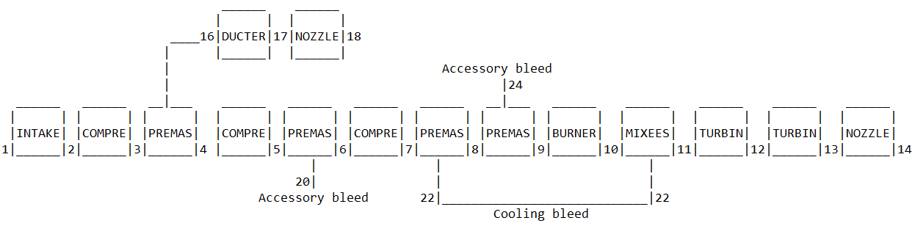

Operating condition | Time (mins) | Input
 |  | Altitude (m) | Mach number | PCN
Taxi | 5 | 0 | 0 | 0.7
Takeoff | 1 | 0 | 0 | 1.1
Climb 1 | 5 | 3000 | 0.5 | 0.9
Climb 2 | 10 | 7000 | 0.7 | 0.8
Cruise | 123 | 10000 | 0.8 | 1
Low Rating | 30 | 5000 | 0.75 | 0.7
Reverse Thrust | 1 | 0 | 0.4 | 1.1
Taxi | 5 | 0 | 0 | 0.7

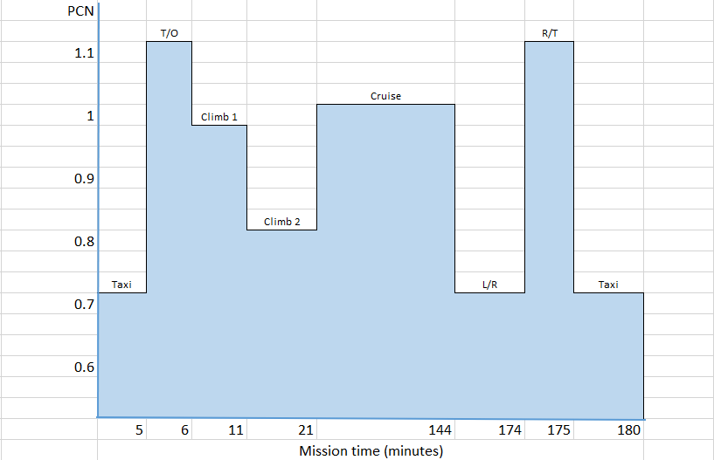

Assuming that we have been able to determine the operating temperatures and
stress levels, from the Larson-Miller chart we can provide the parameter P in
the equation:
$$P= \frac{T}{1000}(Log{ t}_{f}+20)$$
Where,
T = Temperature K (TET)
tf = Time to failure

The TET-Stress correlation is provided below:

TET (K) | Stress (MPa)
1570 | 350
1525 | 300
1290 | 265
1215 | 250
1070 | 200
1040 | 150
900 | 100

The stress-LMP correlation is provided below:

Stress (MPa) | P
100 | 37.0
150 | 36.0
200 | 35.0
250 | 34.5
265 | 34.1
300 | 34.0
350 | 33.9

Operating condition | Time (mins) | Input |  |  | Output |  |  | Stress (Mpa) | P | tf (hours)
 |  | Altitude (m) | Mach number | PCN | Net Thrust | Fuel flow | Turbine inlet T₁₁
Taxi | 5 | 0 | 0 | 0.7
Takeoff | 1 | 0 | 0 | 1.1
Climb 1 | 5 | 3000 | 0.5 | 0.9
Climb 2 | 10 | 7000 | 0.7 | 0.8
Cruise | 123 | 10000 | 0.8 | 1
Low Rating | 30 | 5000 | 0.75 | 0.7
Reverse Thrust | 1 | 0 | 0.4 | 1.1
Taxi | 5 | 0 | 0 | 0.7

Operating condition | Time (mins) | tf (hours) | T/tf
Taxi | 5
Takeoff | 1
Climb 1 | 5
Climb 2 | 10
Cruise | 123
Low Rating | 30
Reverse Thrust | 1
Taxi | 5
Total | 180

- Total number of cycles using Miner’s Law, N = 1/(Total T/tf)
= ____________
- Applying FOS = 1.5, the number of cycles, Nfos = N/1.5
= ____________
- Total number of hours before failure criteria, T = Nfos x 180/60
= _____________

Simulation exercise 5

Using -3 in compressor efficiency degradation index (%) to represent fan degradation

Operating condition | Time (mins) | Input |  |  | Output |  |  | Stress (Mpa) | P | tf (hours)
 |  | Altitude (m) | Mach number | PCN | Thrust | Fuel flow | Turbine inlet T₁₁
Taxi | 5 | 0 | 0 | 0.7
Takeoff | 1 | 0 | 0 | 1.1
Climb 1 | 5 | 3000 | 0.5 | 0.9
Climb 2 | 10 | 7000 | 0.7 | 0.8
Cruise | 123 | 10000 | 0.8 | 1
Low Rating | 30 | 5000 | 0.75 | 0.7
Reverse Thrust | 1 | 0 | 0.4 | 1.1
Taxi | 5 | 0 | 0 | 0.7

Operating condition | Time (mins) | tf (hours) | T/tf
Taxi | 5
Takeoff | 1
Climb 1 | 5
Climb 2 | 10
Cruise | 123
Low Rating | 30
Reverse Thrust | 1
Taxi | 5
Total | 180

- Total number of cycles using Miner’s Law, N = 1/(Total T/tf)
= ____________
- Applying FOS = 1.5, the number of cycles, Nfos = N/1.5
= ____________
- Total number of hours before failure criteria, T = Nfos x 180/60
= _____________

